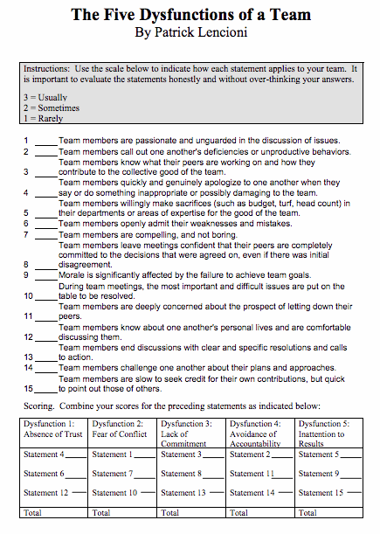
How to Score:
A score of 8-9 probably indicates that your team does not suffer from dysfunction.
A score of 6-7 indicates that dysfunction could be a problem.
A score of 3-5 indicates that dysfunction should be addressed.
Taking the temperature of your organization: Is it healthy?
Anja Wynne, PhD; Assistant Director, HR Compliance, awynne@uccs.edu
PDC, June 20, 2016
Based on the 2012 work of Patrick Lencioni’s The Advantage: Why organizational health trumps everything else in business.

- Build a cohesive [leadership] team
_______________________________________________________________________________________________________________________________________________________________________________________________________________________________________________________________
_____________________________________________________________________________________
- Create clarity
____________________________________________________________________________________________________________________________________________________________________________________________________________________________________________________________________________________________________________________________________________________
- Over communicate clarity
____________________________________________________________________________________________________________________________________________________________________________________________________________________________________________________________________________________________________________________________________________________
- Reinforce clarity
____________________________________________________________________________________________________________________________________________________________________________________________________________________________________________________________________________________________________________________________________________________

